C E R T I F I C A T I O N

TO WHOM IT MAY CONCERN:

This is to certify that ______________________________________ and ________________________________, both of which are _______ years old and both with postal address of ______________________________ St. Bo. Obrero Tondo, Manila, is the same person and resident of Barangay 192.

This certification was issued upon the request of the above-mentioned name for any legal purposes that may serve him/her best.

Issued at the office of the Barangay Chairman, Barangay 192 Zone-17 Dist. II this _____ day of _____________, ______City of Manila.

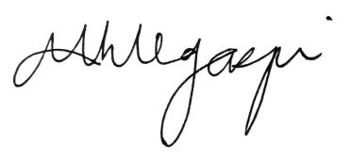

MARIA MAGDALENA H. LEGASPI
Barangay Chairwoman

